**2024 Mike Colalillo Medal of Honor**

**Scholarship Application**

***The 2024 application deadline is******Monday, September 30, 2024***

**Applicant status as of the Fall Semester 2024** (check one)

High School Senior  College Freshman  College Sophomore   
 College Junior  College Senior

**Applicant’s Full Name:** Click here to enter text.

**Mailing address:**

**Street**: Click here to enter text.

**City:** Click here to enter text. **State:**  **Zip:** Click here to enter text.

**If temporary, add permanent address:**

**Street**: Click here to enter text.

**City:** Click here to enter text. **State:**  **Zip:**  Click here to enter text.

**E-mail address:** Click here to enter text. **Phone:**  Click here to enter text.

**Date of birth:**  Click here to enter a date. **Place of birth:** Click here to enter text.

**Higher Education Institution:** Click here to enter text.

**Street**: Click here to enter text.

**City:** Click here to enter text. **State:**  **Zip:**  Click here to enter text.

**Academic Advisor:** Click here to enter text.

**E-mail address:** Click here to enter text. **Phone:**  Click here to enter text.

*I have read the eligibility requirements (on the reverse), I am eligible to participate, and I agree to the terms. In addition, I am aware that the research paper will become the property of the St. Louis County Historical Society and may be published online.*

**Applicant signature:** _________________________________**Date:** Click here to enter a date.

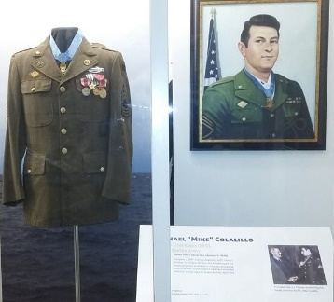**Return applications to:**

Veterans Memorial Hall Program Manager

c/o St. Louis County Historical Society

506 Michigan Street

Duluth, MN 55802

Or electronically by email to the staff members below.

**Eligibility Criteria**

In order to be eligible, *applicants must meet one of the following requirements*:

* A full-time student who is enrolled in a higher education institution in St. Louis County, OR
* A resident of St. Louis County who is a full-time student enrolled in a higher education institution in another county or state, OR
* A high school senior who lives in St. Louis County and plans to attend a higher education institution

**Application Requirement**

Scholarship applicants are required to submit a research paper on a topic relevant to veterans of St. Louis County, Minnesota. The paper must:

* Address a historical event in St. Louis County, Minnesota, related to a conflict, a war or the home front; OR tell the story of a county veteran
* Be a minimum of four (4) and a maximum of ten (10) double-spaced pages in length
* Include at least one source from the Albert J. Amatuzio Research Center, located in at:
  + St. Louis County Depot Building,
  + 506 West Michigan Street, Duluth, MN 55802
* Include a bibliography

Staff members are available to answer questions, suggest possible research topics, and assist with the research from 10 a.m. – 3 p.m., Monday – Friday. Please contact:

**Jay Hagen, VMH Program Manager**

218.733.7500

[jay@thehistorypeople.org](mailto:jay@thehistorypeople.org)

For more information, please visit the St. Louis County Historical Society website:

[Mike Colalillo Medal of Honor Scholarship (thehistorypeople.org)](https://www.thehistorypeople.org/m-colalillo-scholarship).

The research paper will become the property of the Veterans Memorial Hall Program/St. Louis County Historical Society. The Society reserves the right to publish the paper on its website with no additional remuneration.